Step 1: Configure IP Addressing
R1
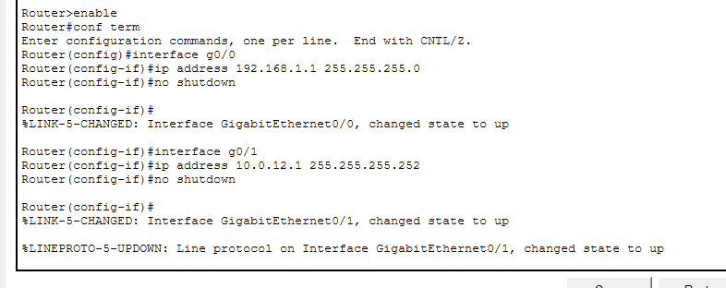
R2
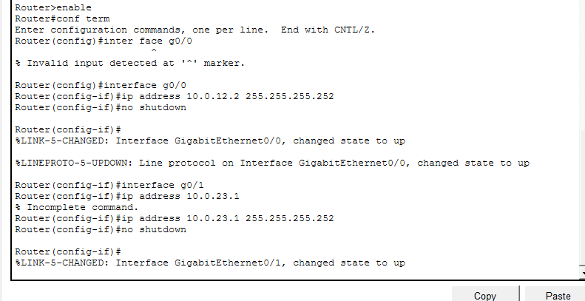
R3
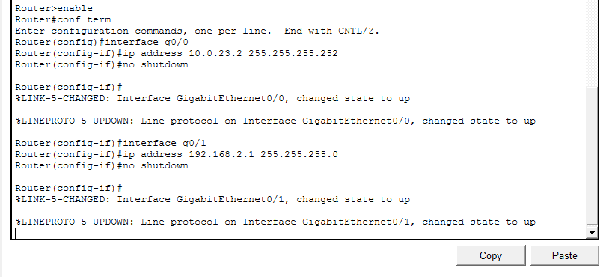
Step 2: Configure OSPF Areas

R1 (Backbone Area 0)
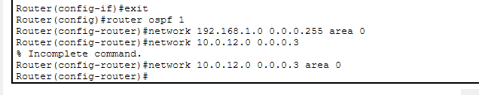

R2 (ABR – connects two areas)
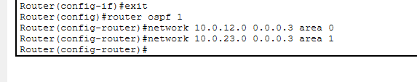

R3 (Area 1)
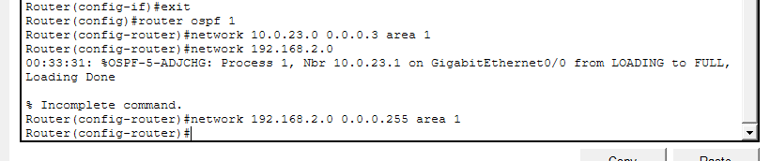

Verification
Show ip ospf neighbor
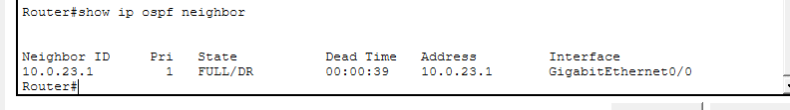
Show ip route
